**Protocol for Artificial Stem Experiments in Flume Test Section**

**Overview of Steps**

1. Construction of artificial stems, begin biofilm growth experiments
2. Calibration Experiments
   1. Calibration without artificial stems to get baseline for particle removal rate due to settling throughout the flume (denoted as *ks* in Fauria 2015, *WRR*)
   2. Characterize flow throughout the test section using the Vectrino, collect at various depths and locations in the test section as well as above and below the test section.
3. Experiment with artificial stems, without biofilm, using kaolinite flocs, silt and, most recently, walnut shell
4. Experiment with artificial stems and biofilm

**Materials and Setup**

Flume measurements

203.5 cm length of glass false bottom

195 cm (conservative low) length of interior of test section at lower floor level

61 cm width

2.5 cm thickness of glass false bottom of test section

1. Obtain ¼ inch thick acrylic sheet; dimensions 77 x 24 inches (195.6 x 60.96 cm); Quote from TAP plastics is $117.17

Other Notes:

* We’re not specifically trying to replicate WLD conditions.

Bottom line:determine constraints:

* Experimental setup/ acrylic sheet positioning
* Cost constraints
* Allowable materials for rods: just wood;
* Rod density range / and rod diameter(s)

**Updated Design 11/1/17**

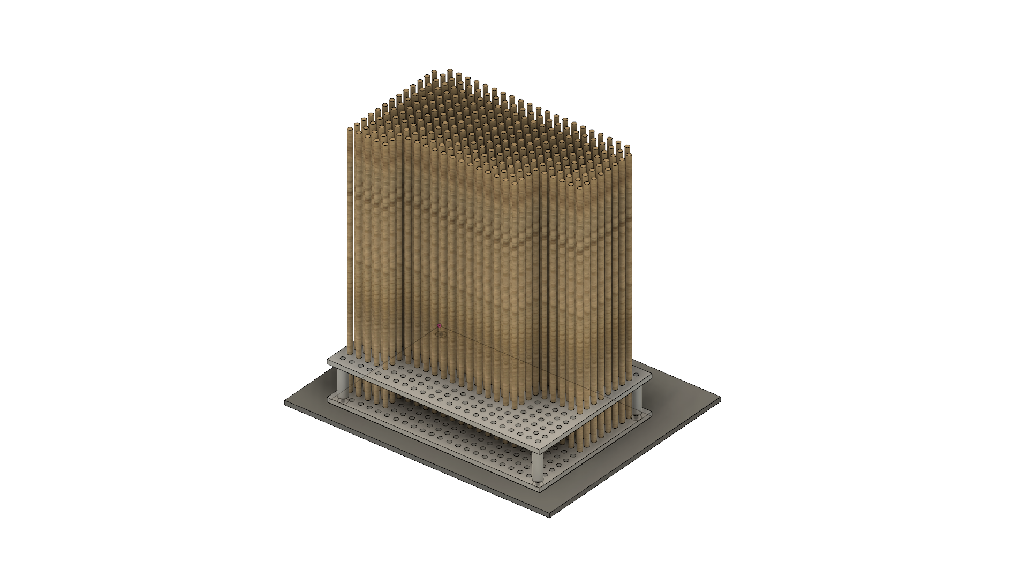

Figure 1. Section of experimental setup. 2 sheets of ¼” PVC with prefabricated ¼” holes at ½” spacing are vertically offset by 2”. A solid sheet of PVC, acrylic, or other material sits behind the lower sheet to support dowels. Additional support legs (not shown) attached to the solid sheet will support the section at a height such that the uppermost sheet is flush with the bed of the flume on the upper and lower ends of the test section. A solid sheet of PVC, acrylic, or other material (not shown) will rest (with some additional deadweight on it) atop the dowels to prevent them from floating up and out of the gridded apparatus.

UPDATE: used staggered hole design, aluminum OK

**Materials:**

dowel:

[**http://woodproducts.caldowel.com/dowel-rod-size-price-chart.aspx**](http://woodproducts.caldowel.com/dowel-rod-size-price-chart.aspx)

<http://www.craftparts.com/dowels-dowel-rods-all-sizes-hardwood-dowel-rods-c-168_169.html>

Perforated sheet:

<http://www.harrisonplastic.com/perforatedsheet.html>

<https://www.mcmaster.com/#standard-perforated-sheets/=1a2kjr3>

McMaster-Carr item numbers (get all at 48”x96”)

92985T57

92985T58

92985T59

Acrylic sheet:

See TAP plastics, quote of ~$120 with in-store pickup

Get below items from McMaster-Carr

Note: If there’s a possibility of using saltwater in the flume (e.g. to make kaolinite flocs), then use marine grade stainless steel components (316 or 316L grade; for example <https://www.mcmaster.com/#threaded-rods/=1d22w6o>)

Threaded rods

Lock Washers, hex-nuts, eye-bolts

*Other materials that might be useful, but don’t buy initially:*

Legs/supports

Cut sections of PVC pipe

<https://www.homedepot.com/p/1-2-in-x-10-ft-600-PSI-Schedule-40-PVC-Plain-End-Pipe-530048/100113200> (10ft of ½” pipe for ~$2)\

Spacers (don’t buy initially, but listed for reference if they are needed)

<https://www.grainger.com/category/round-spacers/spacers-and-standoffs/fasteners/ecatalog/N-8nl#nav=%2Fcategory%2Fround-spacers%2Fspacers-and-standoffs%2Ffasteners%2Fecatalog%2FN-8nlZ1z0o42gZ1z0o42f>

Or <https://www.homedepot.com/p/Everbilt-0-328-in-x-1-in-x-1-2-in-O-D-Nylon-Spacer-815048/204276556>

3/16 ID https://www.mcmaster.com/#unthreaded-spacers/=1a2l1i2

5/16” ID https://www.mcmaster.com/#unthreaded-spacers/=1a2kz2d

**Natural Systems and Experimental Parameters**

|  |  |  |  |  |  |
| --- | --- | --- | --- | --- | --- |
| **Parameter** | **Fauria et al. 2015** | **This Experiment** | **Wax Lake Delta** | **Natural Floodplain** | **Natural Floodplain Reference** |
| Channel Avg Flow Velocity (cm/s) | 1.8; 4.5; 6.1 | 5.7 |  | 0-25 | Valiela et al 1978 |
| Flow Depth (cm) | 14-17 | 40-45 |  | 0-50 | Kadlec 1990 |
| Stem Width (cm) | 0.1-0.6 |  |  | 0.1-1.0 | Nepf 2012 |
| Stem Thickness (cm) | 0.1 |  |  | ~0.1 | Nepf 2012 |
| Stem (Collector) Reynolds Number | 54-183 | 179.09 |  | 5-1000 | Kadlec 1990 |
| Suspended particle concentration (uL/L) | 9-50 |  |  | 9-25 | Aiona 2013 |
| Vegetation Density (stems/m^2) | 0; 2724; 7209 | 183 |  | 0-2500 | Valiela et al 1978 |

Table 1. Natural Systems and Experimental Parameters.Columns ‘Natural Floodplain’ and ‘Natural Floodplain Reference’ from Fauria et al. (2015), Table 2.

**Design Constraints**

|  |  |  |
| --- | --- | --- |
| **Constraint** | **Value/Range** | **Notes** |
| a*d | 0.001-0.07 | unitless |
| Diameter (d) | 0.1 - 0.6 cm | Realistically 0.3cm (⅛”) is smallest dowel available |
| Sheeting material | Plastic or aluminum (or steel?) | High-strength PVC is cheapest and easy to cut and tap. |

Table 2. Design Constraints

**Materials Constraints**

|  |  |  |  |
| --- | --- | --- | --- |
| Dowel diameter  (frac inch / inch / cm) | Perforated sheet hole diameter (add 1/16 inch to dowel diameter)  (frac inch / inch / cm) | Perforated sheet materials available (McMaster-Carr) | Notes |
| 1/8 / .125 / 0.3175 | 3/16 / .1875 / .47625 | PVC, Alum, Steel | *See Table 4* |
| 3/16 / .1875 / 0.47625 | 1/4 / .25 / .635 | Alum, Steel | *PVC available in straight-grid formation* |
| 1/4 / .25 / .635 | 5/16 / 0.3125 / 0.79375 | Steel |  |
| 5/16 / 0.3125 / 0.79375 | ⅜ / .375 / 0.9525 | PVC, Steel | *See Table 5* |
| ⅜ / .375 / 0.9525 | 7/16 / .4375 / 1.11125 | [none] |  |
| 7/16 / .4375 / 1.11125 | ½ / .5 / 1.27 | PVC, Steel | *See Table 6* |

Table 3. Materials constraints.

**Potential Experimental Setups**

Setup A

1/8” dowels with 3/16” holes, staggered spacing, plastic sheet

Setup B

5/16” dowels with ⅜” holes, staggered spacing, plastic sheet

Setup C

7/16” dowels with 1/2” holes, staggered spacing, plastic sheet

**Setup A - Dowel Diameter: 0.3175 cm (⅛”)**

|  |  |  |  |  |
| --- | --- | --- | --- | --- |
| Dowel spacing | Dowel density (dowels / m^2) | Frontal area/unit volume (=N/A*d) | Solid volume fraction | **a*d** |
| Every hole | 18269 | 0.5800 | 0.144638926 | 0.18416 |
| Every other hole | 9135 | 0.2900 | 0.072327317 | 0.09209 |
| Every third hole | 6090 | 0.1933 | 0.048215593 | 0.06139 |
| Every fourth hole | 4567 | 0.1450 | 0.036159731 | 0.04604 |
| Every tenth hole | 1827 | 0.0580 | 0.014467034 | 0.01842 |
| Every hundredth hole | 183 | 0.0058 | 0.001445133 | 0.00184 |

Table 4. (Diameter) * (frontal area / unit volume) for dowel diameter 0.3175 cm

Frontal area/unit volume * d*d * pi /4

**Setup B - Dowel Diameter: 0.79375 cm (5/16”)**

|  |  |  |  |  |
| --- | --- | --- | --- | --- |
| Dowel spacing | Dowel density (dowels / m^2) | Frontal area/unit volume (=N/A*d) | Solid volume fraction | **a*d** |
| Every hole | 5647 | 0.44823 | 0.279428959 | 0.35578 |
| Every other hole | 2824 | 0.22412 | 0.139714479 | 0.17789 |
| Every third hole | 1882 | 0.14941 | 0.093140368 | 0.11859 |
| Every fourth hole | 1412 | 0.11206 | 0.069861167 | 0.08895 |
| Every tenth hole | 565 | 0.04482 | 0.027936613 | 0.03557 |
| Every hundredth hole | 57 | 0.00448 | 0.002796017 | 0.00356 |

Table 5. (Diameter) * (frontal area / unit volume) for dowel diameter 0.79375 cm

**Setup C - Dowel Diameter: 1.11125 cm (7/16”)**

|  |  |  |  |  |
| --- | --- | --- | --- | --- |
| Dowel spacing | Dowel density (dowels / m^2) | Frontal area/unit volume (=N/A*d) | Solid volume fraction | **a*d** |
| Every hole | 3781 | 0.42016 | 0.366710256 | 0.46691 |
| Every other hole | 1891 | 0.21008 | 0.183351201 | 0.23345 |
| Every third hole | 1260 | 0.14005 | 0.12223937 | 0.15564 |
| Every fourth hole | 945 | 0.10504 | 0.091679528 | 0.11673 |
| Every tenth hole | 378 | 0.04202 | 0.03667024 | 0.04669 |
| Every hundredth hole | 38 | 0.00420 | 0.003667809 | 0.00467 |

Table 6. (Diameter) * (frontal area / unit volume) for dowel diameter 1.11125 cm

**Material Sourcing and Costs - Setup A**

|  |  |  |  |  |  |
| --- | --- | --- | --- | --- | --- |
| **Component** | **Supplier** | **Link to part** | **Unit cost** | **Total cost (excluding shipping)** | **Notes** |
| Birch Dowel, 48” length | Macbeath Hardwood | https://www.macbeath.com/product/birch-dowel | $0.34 | Up to $1,242.36 (for the 6090/m^2 density) | 48” makes two dowels for experiment; need up to 3654 for high density config |
| PVC perforated sheet, 3/16” diameter | McMaster Carr | https://www.mcmaster.com/#92985T56 | $145.50 | $145.50  Note: will need cut to size; may incur additional cost | Need one 48”x96” sheet, Physics Machine Shop (UCB) will cut to size; talk to Warner Carlisle |

Table 7: Setup A (⅛” dowels, 3/16” perforated sheet)

**Material Sourcing and Costs - Setup B**

|  |  |  |  |  |  |
| --- | --- | --- | --- | --- | --- |
| **Component** | **Supplier** | **Link to part** | **Unit cost** | **Total cost (excluding shipping)** | **Notes** |
| Birch Dowel, 48” length | Macbeath Hardwood | https://www.macbeath.com/product/birch-dowel | $2.17 | Up to $735.63 (for the 565/m^2 density) | 48” makes two dowels for experiment; need up to 339 for high density config |
| PVC perforated sheet, 3/8” diameter | McMaster Carr | https://www.mcmaster.com/#92985T58 | $175.80 | $175.80  Note: will need cut to size; may incur additional cost | Need one 48”x96” sheet, Physics Machine Shop (UCB) will cut to size; talk to Warner Carlisle |

Table 8: Setup B (5/16” dowels, 3/8” perforated sheet)

**Material Sourcing and Costs - Setup C**

|  |  |  |  |  |  |
| --- | --- | --- | --- | --- | --- |
| **Component** | **Supplier** | **Link to part** | **Unit cost** | **Total cost (excluding shipping)** | **Notes** |
| Birch Dowel, 48” length | Macbeath Hardwood | https://www.macbeath.com/product/birch-dowel | $2.73 | Up to $619.17 (for the 378/m^2 density) | 48” makes two dowels for experiment; need up to 227 for high density config |
| PVC perforated sheet, 1/2” diameter | McMaster Carr | https://www.mcmaster.com/#92985T59 | $250.51 | $250.51  Note: will need cut to size; may incur additional cost | Need one 48”x96” sheet, Physics Machine Shop (UCB) will cut to size; talk to Warner Carlisle |

Table 9: Setup C (7/16” dowels, 3/8” perforated sheet)

**Additional components** (reusable among setups)

* **Walnut Shell Flour**, Compomat, [https://compomat.com/walnut-shell-blast-media](https://compomat.com/walnut-shell-blast-media/) (mesh sizes -100, -200, and -325)
  + Note: they generally don’t sell in quantities below 50 lbs; if they’re hesitant, mention that you’ve done this before and also may be interested in buying more later. They have, in the past, shipped several pounds in a double-bagged gallon ziplock bag for a flat rate of $50.
* **Threaded rods, eye bolts, hex nuts**, McMaster Carr
  + 8-32 thread size 12-inch threaded rods
  + - Quantity: 16
  + -<https://www.mcmaster.com/#93250a052/=1buwcsx>
  + #8 screw size washers
  + - Quantity: 1 pack of 100
  + -<https://www.mcmaster.com/#90107a010/=1buwde>
  + 8-32 thread size hex nuts
  + - Quantity: 1 pack of 100
  + -<https://www.mcmaster.com/#90257A009>
  + 10-24 thread size hex nuts
  + - Quantity: 1 pack of 100
  + -<https://www.mcmaster.com/#90257A011>
  + #8 screw size split lock washers
  + - Quantity: 1 pack of 100
  + -<https://www.mcmaster.com/#92147a425/=1buwqup>
  + 10-24 thread size eyebolts
  + - Quantity: 10
  + -<https://www.mcmaster.com/#9489t514/=1buwwo1>
* **Wall putty**, Target
  + As counterweight for the ⅛” dowels so they don’t float
* **Silicone grease**, Ebay
  + for coating the dowels to imitate the stickiness of biofilms
  + <https://www.ebay.com/itm/NEW-CHEMPLEX-710-FUSER-FILM-SLEVE-SILICONE-COMPOUND-GREASE-HP-LEXMARK-5-3-OZ-/261554591487>